CSCI – 6655

Mid-term

Name - Darshan kumar Munireddy

Student ID – 00760186

Email – [dmuni1@unh.newhaven.edu](mailto:dmuni1@unh.newhaven.edu)

1.

A website ca be defined as a collection of webpages which contains all the required information about you and the services you offer or the business you do. It is like a digital business card with all the information that can be accessed by clicking on a link. It accumulates all the required information at one place which is hosted by a server and can be accessed through internet.

Basic websites are built using html, css and javascript. They may contain text, photos, documents, etc that users may access. Modern websites are built dynamically to be responsive and also adjust to the dimensions of the screen on which it is being displayed i.e mobile phones, laptop and other devices.

A web application is a type of software that operates on web servers and can be defined as websites with interactive functionality. They are designed to work smoothly across different devices and platforms. Web applications are essentially websites with interactive features, but they are more complex to develop compared to static web pages.

Developing a web application typically requires a significant amount of time because they are dynamic and often involve server-side processing. They need to connect to databases and perform various tasks such as collecting user data, handling online orders, and managing bank transactions. Web applications are closely tied to databases and rely on web servers and application servers for their functionality.

To create a web application, developers commonly use programming languages like PHP, Python, Ruby, and others. These technologies and languages are chosen based on the specific requirements and goals of the project. Additionally, developers have access to various frameworks, libraries, and tools that aid in the development of web applications.

2.

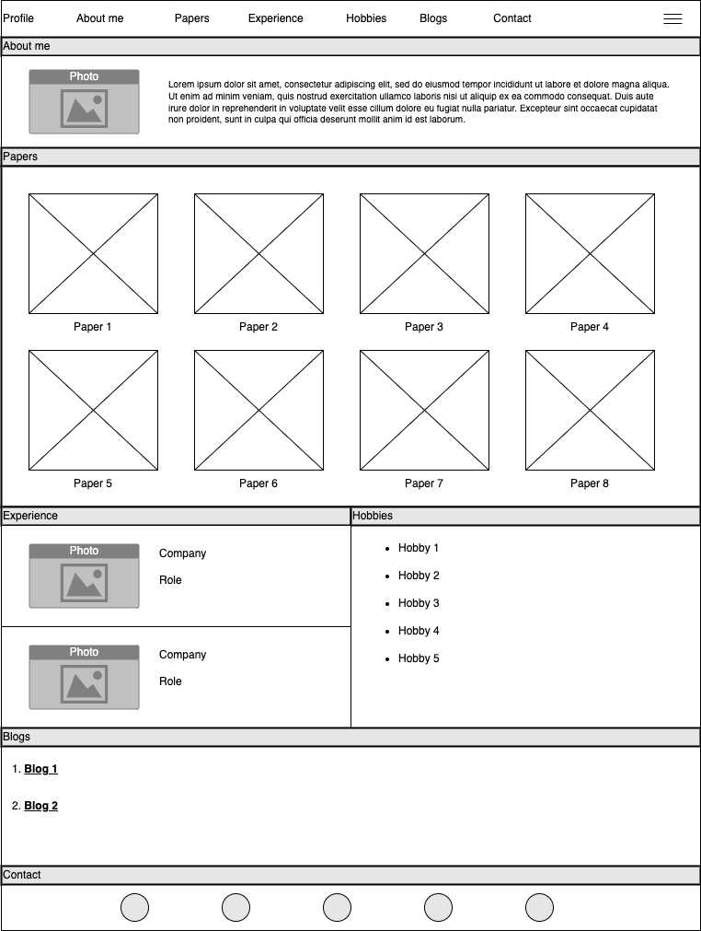

3.

4.

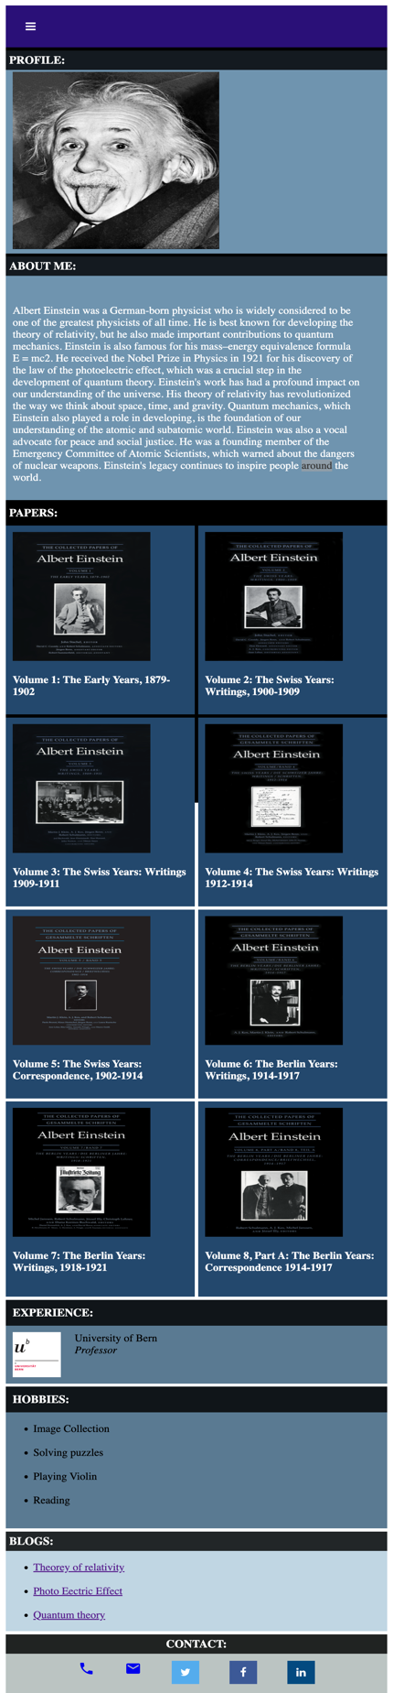

5.

